Contents
3. Geometry & Trigonometry 3
SL 3.1. 3d space, volume, angles, distance, midpoints 3
3.1.1. Three-Dimensional Coordinate System 3
3.1.2. Distance Between Two Points in 3D Space 3
3.1.3. Midpoint in 3D Space 3
3.1.4. Volume and Surface Area of 3D Solids 3
3.1.4.1. Right Pyramid 3
3.1.4.2. Right Cone 4
3.1.4.3. Sphere 4
3.1.4.4. Hemisphere 4
SL 3.2. 2d and 3d trig, sine rule, cosine rule, area 5
3.2.1. Trigonometric Ratios in Right-Angled Triangles 5
3.2.2. The Sine Rule 5
3.2.3. The Cosine Rule 6
SL 3.3. Applications: angles of elevation and depression, bearings 8
3.3.1. Trigonometric Applications in Real-World Scenarios 8
3.3.1.1. Angles of Elevation and Depression 8
3.3.1.2. Angle of Elevation 8
3.3.1.3. Angle of Depression 8
3.3.2. Bearings 9
3.3.2.1. Three-Figure Bearings 9
3.3.2.2. Calculating Bearings 9
SL 3.4-Circle: radians, arcs, sectors 10
3.4.1. Radian Measure of Angles 10
3.4.2. Length of an Arc 10
3.4.3. Area of a Sector 11
3.4.4. Relationship Between Arc Length and Sector Area 11
3.4.5. Expressing Answers 11
SL 3.5. Unit circle definitions of sin, cos, tan. Exact trig ratios, 12
ambiguous case of sine rule 12
3.5.1. Unit Circle Definitions and Exact Trigonometric Ratios 12
3.5.1.1. The Unit Circle 12
3.5.1.2. Unit Circle and Ratios 12
3.5.1.3. The Ambiguous Case of the Sine Rule 13
3.6.1. Pythagorean Identity 14
3.6.2. Double Angle Identities 14
SL 3.7. Circular functions: graphs, composites, transformations 15
3.7.1. Circular functions: Graphs, Composites, and Transformations 15
3.7.1.1. Sine and Cosine 15
3.7.1.2. Tangent 15

3. Geometry & Trigonometry

SL 3.1. 3d space, volume, angles, distance, midpoints

3.1.1. Three-Dimensional Coordinate System
The three-dimensional coordinate system extends the 2D plane into 3D space by adding a third axis, typically labeled z. Points in 3D space are represented by ordered triples .

3.1.2. Distance Between Two Points in 3D Space
The distance formula in 3D is an extension of the 2D Pythagorean theorem:
Where and are the coordinate of the two points
Example: Calculate the distance between points to
- and
- and

3.1.3. Midpoint in 3D Space
The midpoint formula in 3D is a straightforward extension of the 2D version:
Formular
Example: 1. Find the midpoint of the line segment connecting and .
- Find the midpoint of the line segment connecting and .

3.1.4. Volume and Surface Area of 3D Solids

3.1.4.1. Right Pyramid
A right pyramid has a polygonal base and triangular faces that meet at a point (apex) directly above the center of the base.
Volume: , where is the area of the base and is the height of Pyramid
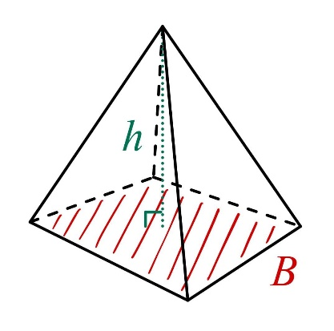

3.1.4.2. Right Cone
A right cone has a circular base with a point (apex) directly above its center.
Volume: , where r is the radius of the base and is the height
Surface Area: , where is the slant height.

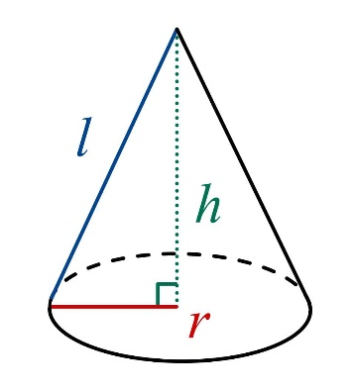

3.1.4.3. Sphere
Volume: , where r is the radius
Surface Area:
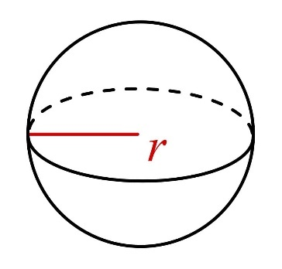

3.1.4.4. Hemisphere
Volume:
Surface Area: (Including the circular base)

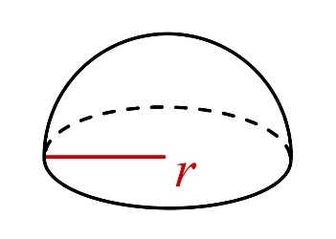

Example:
- Find the volume of square pyramid with base side 6 units and height 8 units.
- Find the volume and surface area of cone with radius 3 units and height 4 units.
- Find the volume and surface area of a sphere has a radius 7 cm.
- Find the volume and surface area of a hemisphere has a radius 5cm.

SL 3.2. 2d and 3d trig, sine rule, cosine rule, area

3.2.1. Trigonometric Ratios in Right-Angled Triangles
Trigonometric ratios are ratios of sides of right-angled triangles, dependent on the angles in the triangle. To make use of these, we label the sides on a triangle with relation to an angle .
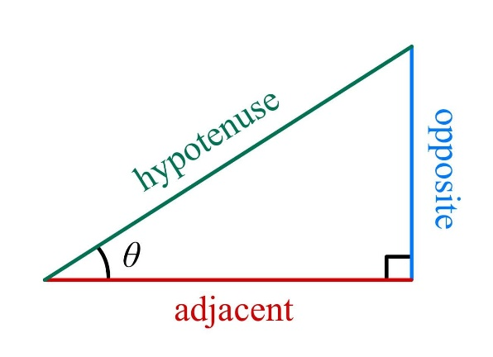
- The hypotenuse is the longest side of the right-angled triangle, opposite the right angle.
- The opposite side to an angle is the only side the angle does not touch.
- The adjacent side to an angle is the only non-hypotenuse side the angle touches.
The three primary ratios are sine, cosine, and tangent.
For a right-angled triangle with an angle θ:

3.2.2. The Sine Rule
The sine rule is used in non-right triangles when we know:
- Two angles and one side, or
- Two sides and the angle opposite one of them
The sine rule states:
Where a, b, and c are the lengths of the sides opposite to angles A, B and C respectively.
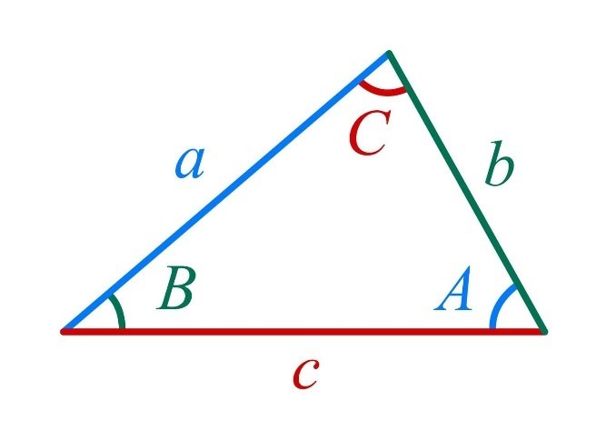

3.2.3. The Cosine Rule
The cosine rule is used when we know:
- Three sides of a triangle, or
- Two sides and the included angle
The cosine rules states:

This can be rearranged to find an angle:
Area of a Triangle
For any triangle, the area can be calculated using the formula:
Where a and b are any two sides, and C is the angle between them.

Example:
- In the following triangle, find .
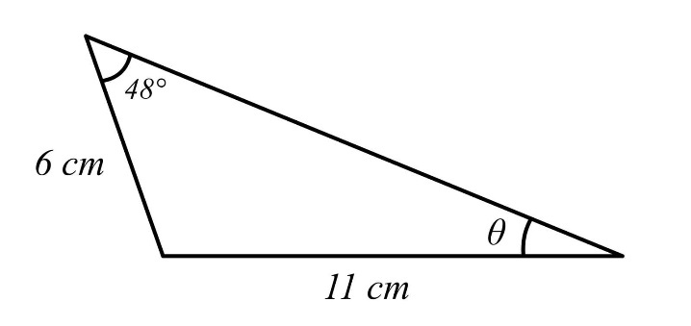
- Find the side length in the following triangle.
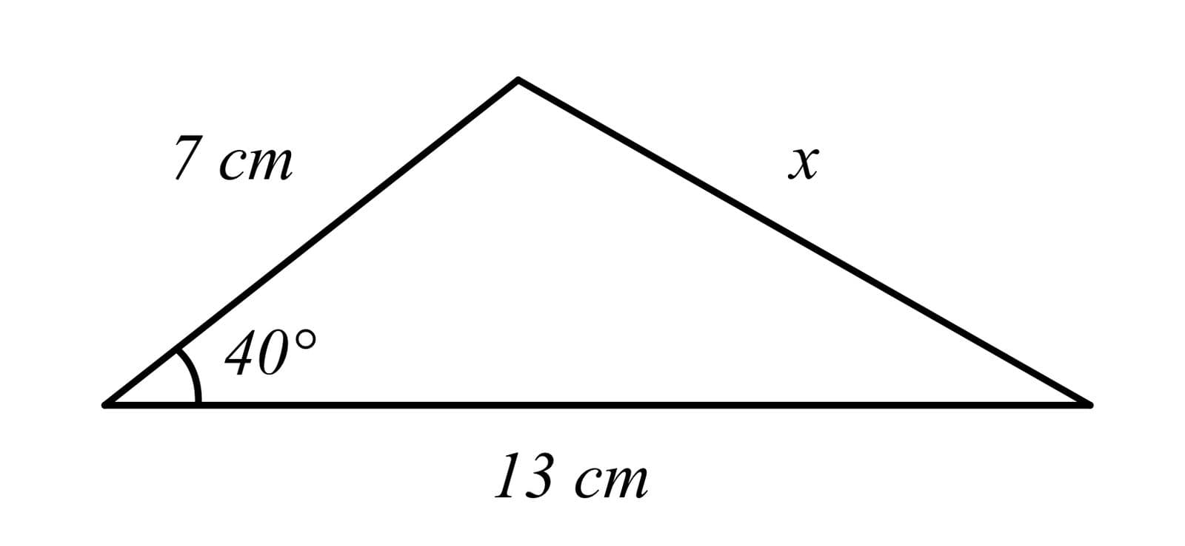
- Find the area of the following triangle:
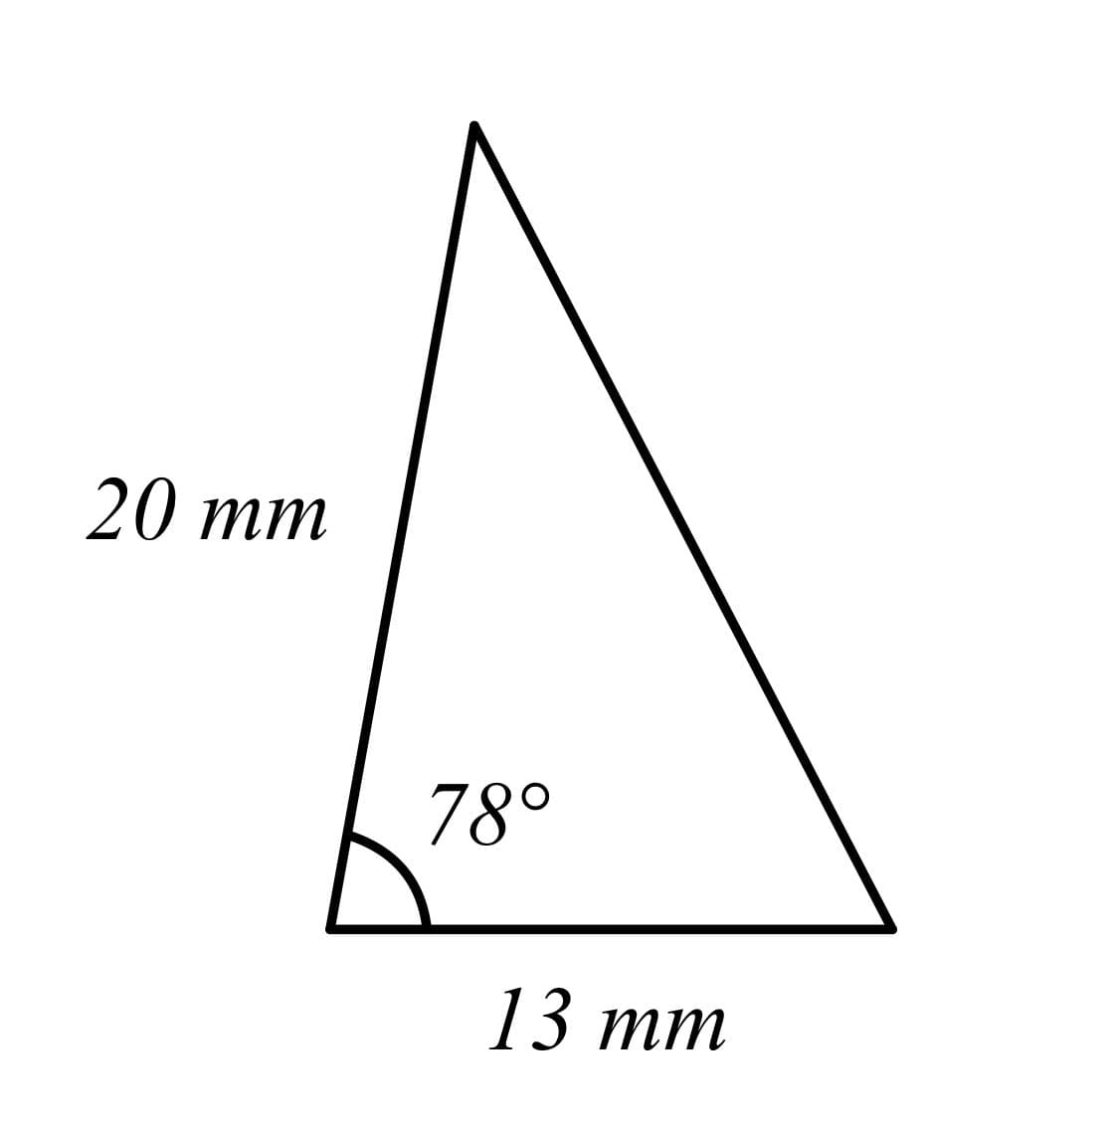

SL 3.3. Applications: angles of elevation and depression, bearings

3.3.1. Trigonometric Applications in Real-World Scenarios

3.3.1.1. Angles of Elevation and Depression
Ever wondered how people measured the heights of big things before the "measure" tool on phones? This is how. They had to look up tangents of angles in a book listing all of them, but luckily, we have calculators.

3.3.1.2. Angle of Elevation
An angle of elevation is the angle formed between the horizontal line of sight and a line of sight pointing upwards towards an object. It is measured from the horizontal to the line of sight.
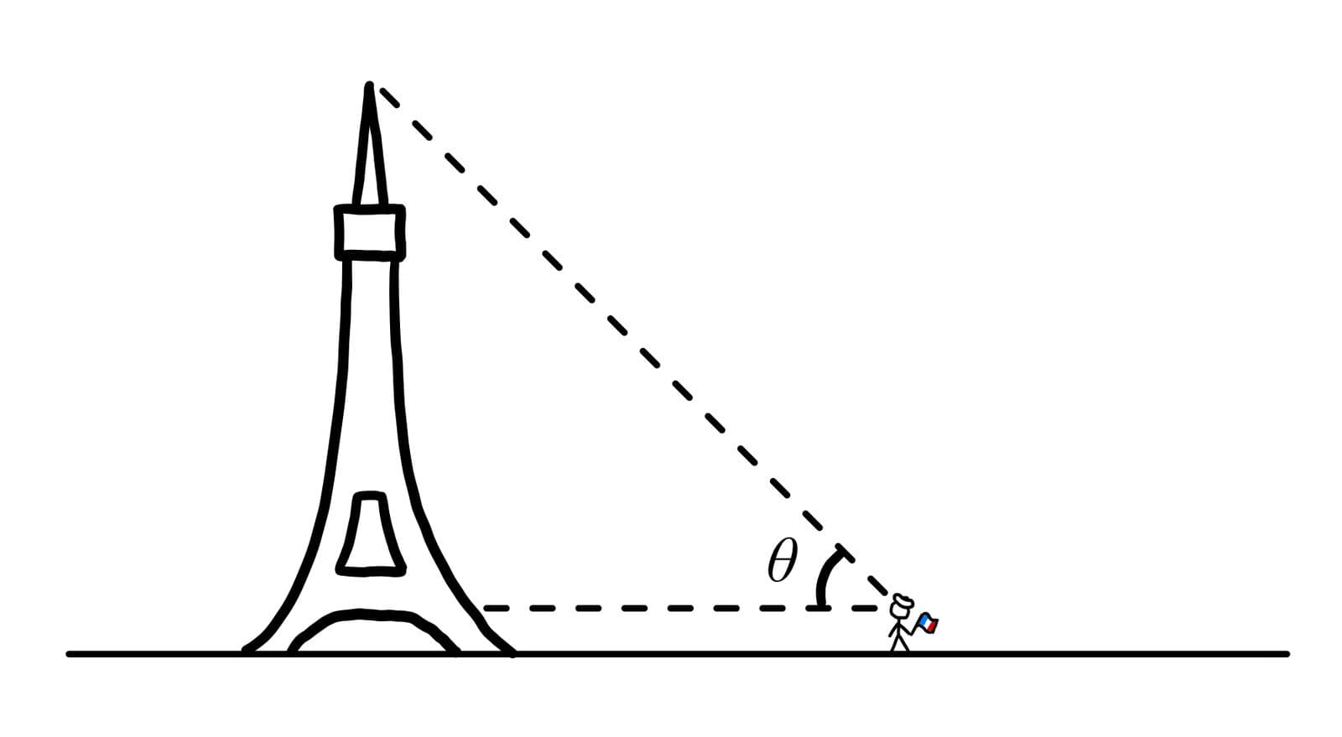
Example: A person standing 20 meters away from a building looks up at the top of the building with an angle of elevation of 30°. Find the height of the building?

3.3.1.3. Angle of Depression
An angle of depression is the angle formed between the horizontal line of sight and a line of sight pointing downwards towards an object. It is measured from the horizontal to the line of sight.
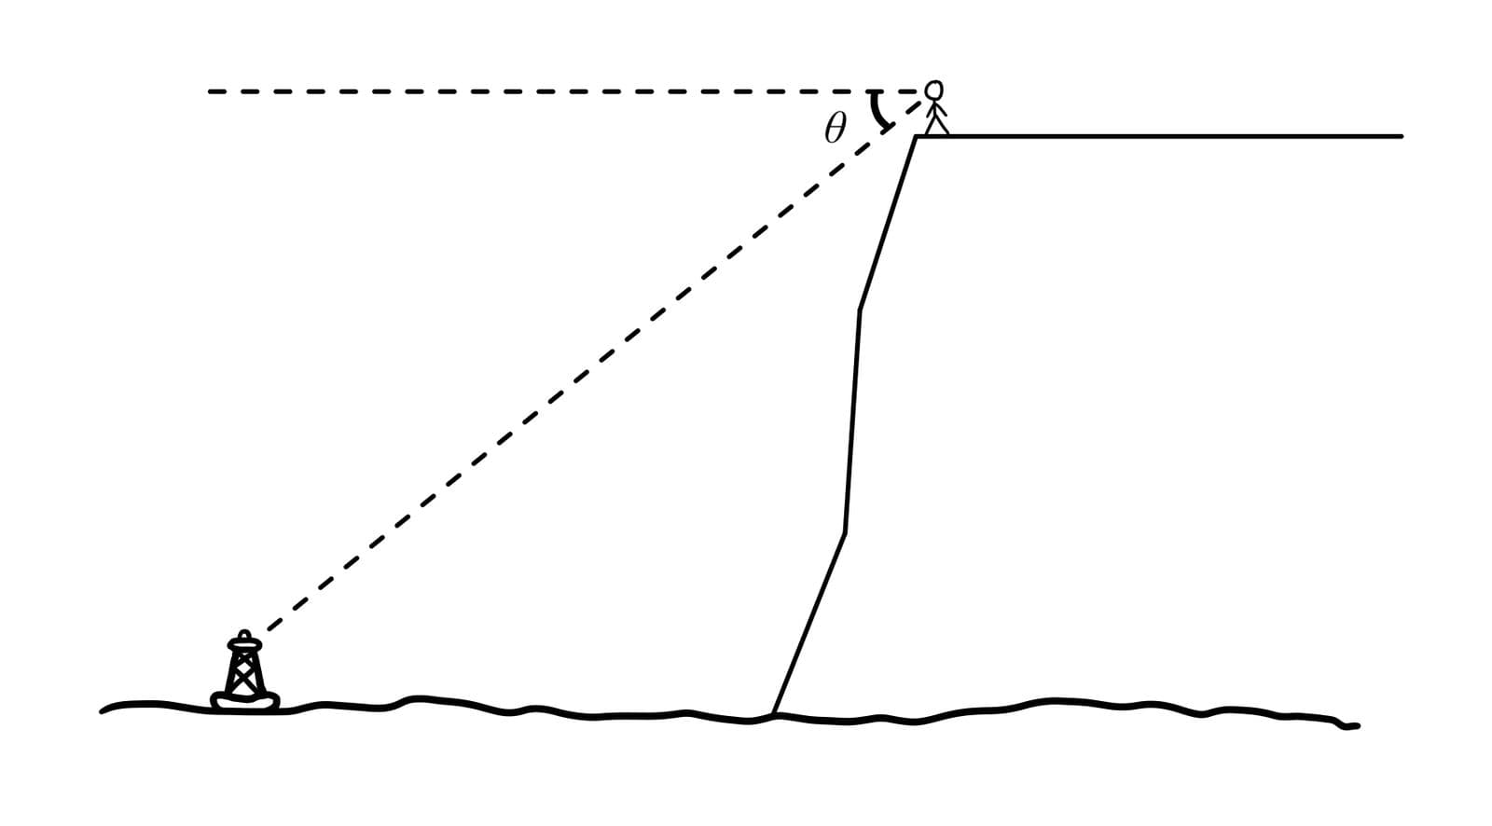
Example: A person standing on a cliff 100 meters high looks down at a boat in the sea with an angle of depression of 25°. Find the distance of the boat from the base of the cliff?

3.3.2. Bearings
Bearings are used to describe directions and are commonly applied in navigation, surveying, and other fields requiring precise directional information.

3.3.2.1. Three-Figure Bearings
A three-figure bearing is measured clockwise from the North, always given as three digits from 000° to 359°.
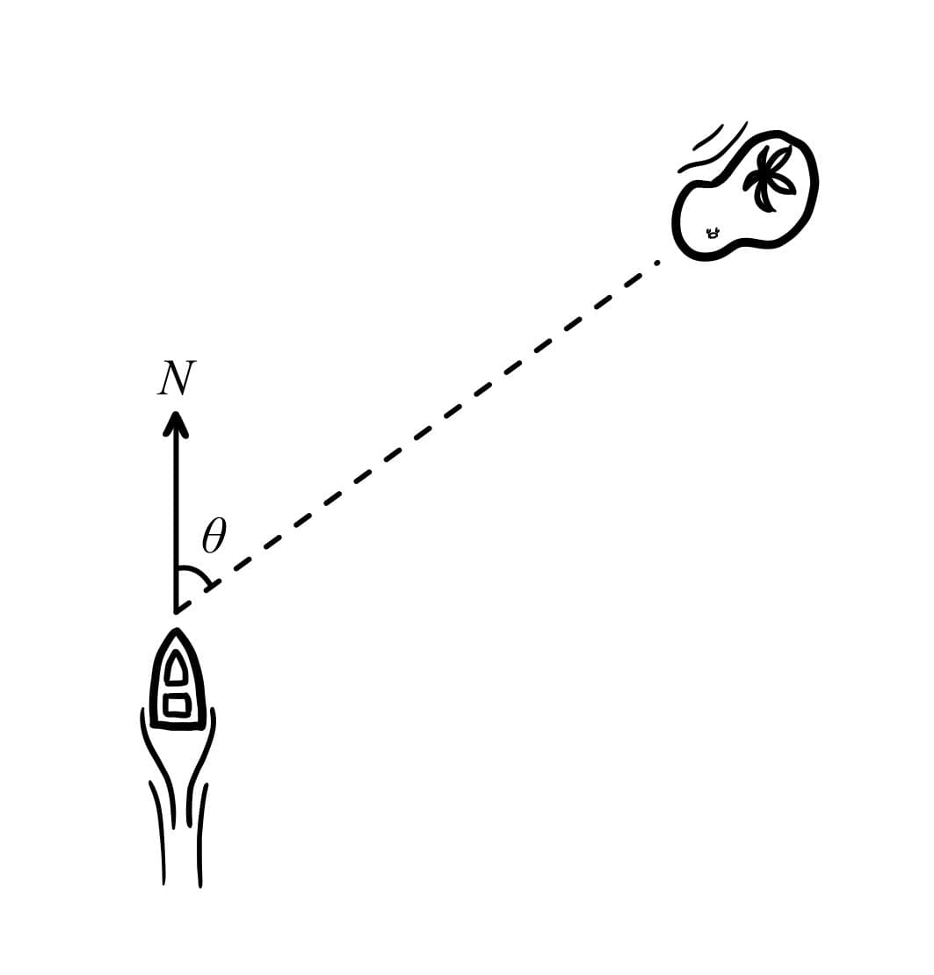
Example: To express East as a bearing: 090° To express South-West as a bearing: 225°.

3.3.2.2. Calculating Bearings
Bearings can be calculated using trigonometric functions, often requiring the use of non-right angled triangle formulas such as the sine and cosine rules.
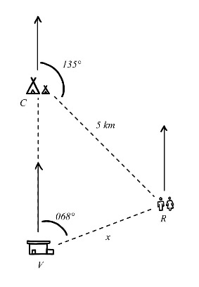
Example: In a national park, there are three locations: the visitor center , the campsite , and the restroom , The campsite is directly north of the visitor center. The restroom is at a bearing of from the visitor center and from the campsite. The distance between the campsite and the restroom is. Find the distance between the visitor center and the restroom.

SL 3.4-Circle: radians, arcs, sectors

3.4.1. Radian Measure of Angles
Radian measure is a way of describing angles using the radius of a circle. One radian is defined as the angle subtended at the center of a circle by an arc length equal to the radius of the circle.
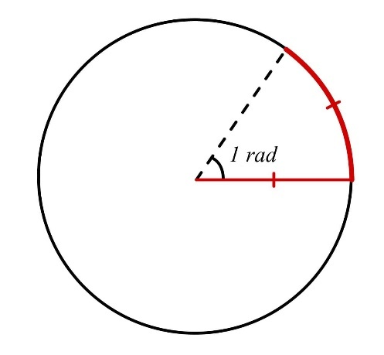
Note:
- is approximately equal to
- The full angle around a circle is 2π radians, which is equivalent to 360°
- The formula for converting between degrees and radians is:
=
Example:
- Convert to the angles in radians.
- Convert to the angles in radians.
- Convert to the angles in degrees.
- Convert to the angles in degrees.

3.4.2. Length of an Arc
The length of an arc is a portion of the circumference of a circle. The portion of the circumference an arc takes up is where is the angle subtended by the arc in radians. This should (hopefully) be intuitive. Therefore,
Where:
- is the radius of the circle
- is the angle subtended by the arc in radians
Example: Calculate the length of an arc that subtends an angle of radians in a circle with radius 5 cm.

3.4.3. Area of a Sector
A sector is a region of a circle enclosed by two radii and an arc. The proportion of the area a sector takes up is also , where is the angle subtended by the sector in radians. Thus,
Where:
- is the radius of the circle
- is the angle subtended by the sector in radians
Example: Calculate the area of a sector with central angle rad in a circle with radius 8 cm.

3.4.4. Relationship Between Arc Length and Sector Area
There's a neat relationship between arc length and sector area that can be useful to remember.
This relationship can be seen by comparing the formulas:
You can substitute arc length into the formula for sector area, which gives you the relationship:

3.4.5. Expressing Answers
It's important to express answers appropriately in your exams so you don't get docked marks. When working with radians and π:
- Exact answers should be given in terms of π when possible. For example, rather than 2.0944. (Sorry, engineers)
- When a decimal approximation is required, use an appropriate number of decimal places or significant figures as specified in the question. If unspecified, always go with 3 significant figures. This is written on the front of your exam paper.
Example
Express the area of sector with radius 10 cm and central angle :
- Convert angle to radians.
- Calculate area.
- Decimal approximation.

SL 3.5. Unit circle definitions of sin, cos, tan. Exact trig ratios,

ambiguous case of sine rule

3.5.1. Unit Circle Definitions and Exact Trigonometric Ratios

3.5.1.1. The Unit Circle
The unit circle is a circle with radius 1 centered at the origin (0,0)
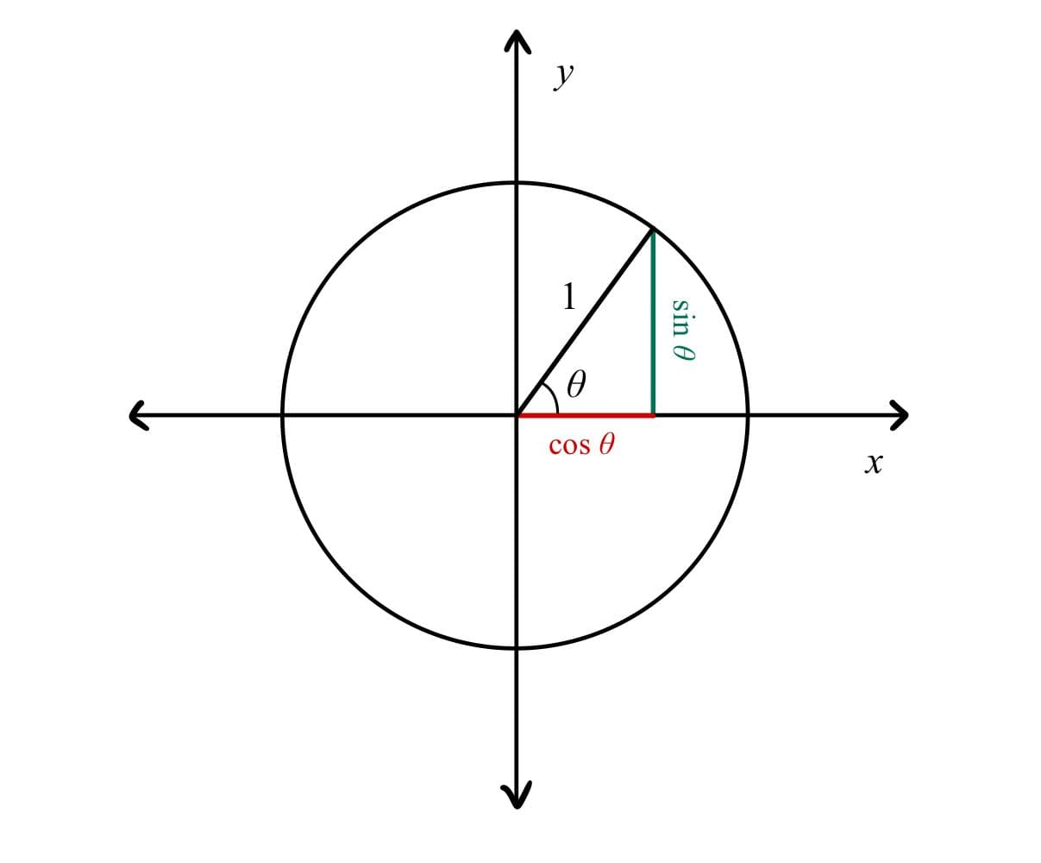

On the unit circle:
- The x-coordinate is
- The y-coordinate is
- The slope of the radius line is
Remember that any point on the unit circle can be written as because the radius is always 1.

3.5.1.2. Unit Circle and Ratios
Depending on which quadrant is in, the values of , may change sign.
- Since is correlated with the -value of the point on the unit circle, is positive in the first and second quadrants (), and negative in the third and fourth ().
- Since is correlated with the -value of the point on the unit circle, is positive in the first and fourth quadrants (), and negative in the second and third ().
- Since is correlated with the slope of the line to the point on the unit circle, is positive in the first and third quadrants () and negative in the second and fourth quadrants ().
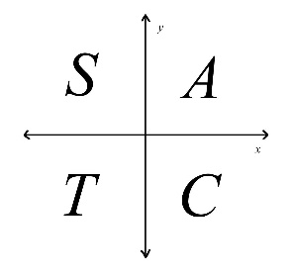
Note:
Some students use the mnemonic "All Students Take Calculus" for which trigonometric functions are positive in which quadrants.
- All functions are positive in the first quadrant.
- Sine is positive in the second quadrant.
- Tangent is positive in the third quadrant.
- Cosine is positive in the fourth quadrant.

3.5.1.3. The Ambiguous Case of the Sine Rule
The sine rule states:
When using the sine rule to solve for an angle, we sometimes get two possible solutions. This is called the ambiguous case.
Example: Find the angle B with the given side , side and angle .
Note: Don't assume there's always only one solution when using the sine rule to find an angle. Check if you're in the ambiguous case.
The ambiguous case occurs when:
- You're solving for an angle using the sine rule
- The angle you're solving for could be acute or obtuse
- The given side is shorter than the side opposite to the given angle
3.5.1.4. Understanding When Two Solutions Exist
For the ambiguous case to be possible:
- The side opposite to the unknown angle must be shorter than the side opposite to the known angle.
- The known angle must be less than 90°
- The ratio must be less than or equal to 1
Note: If any of these conditions aren't met, you'll either have one solution or no solution at all!
SL 3.6. Pythagorean identity, double angles

3.6.1. Pythagorean Identity
Let’s start with this triangle again
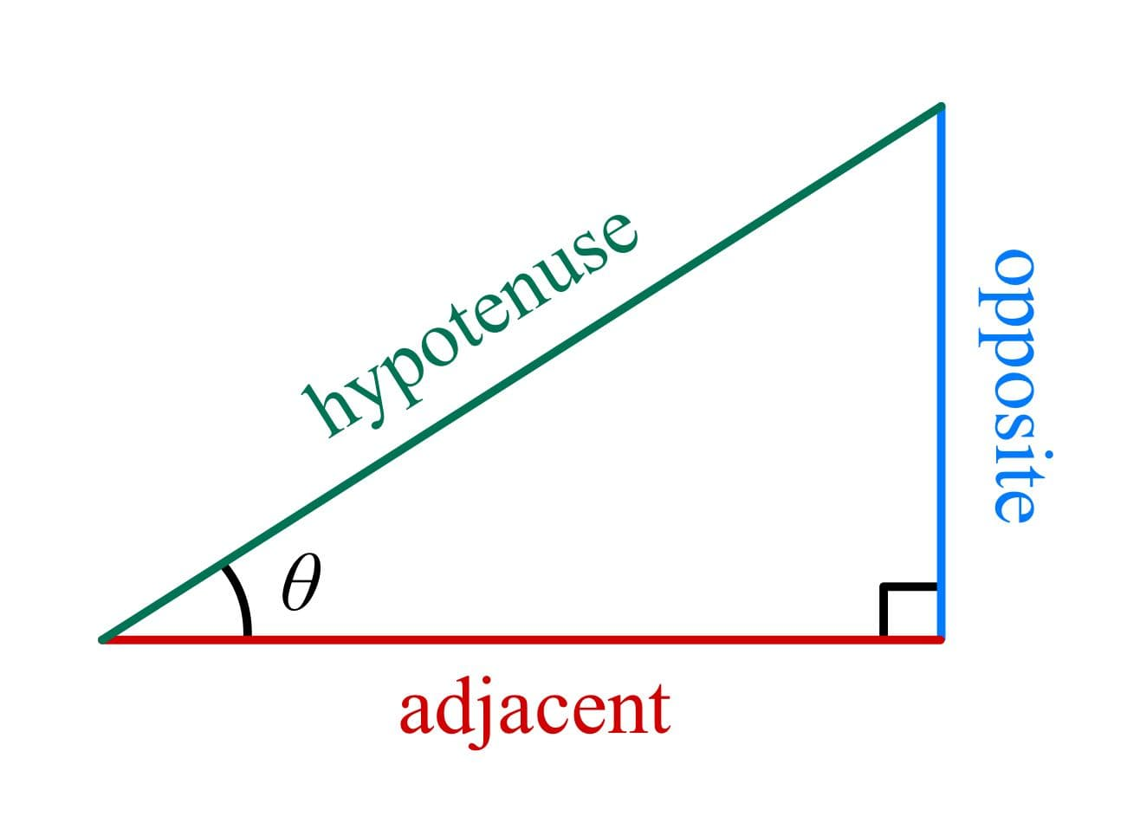
Let's label the sides , , and for brevity.
Now, with the Pythagorean theorem, we can write:
Dividing both sides by we get:
But and . So, the above simplifies to:
This is the Pythagorean identity in trigonometry.

3.6.2. Double Angle Identities
Double angle identities express trigonometric functions of 2θ in terms of functions of θ. The two most important double angle identities are for sine and cosine:

Example:
- Let’s use the double angle identity to verify and .
- Given and is acute, findwithout finding .

SL 3.7. Circular functions: graphs, composites, transformations

3.7.1. Circular functions: Graphs, Composites, and Transformations

3.7.1.1. Sine and Cosine
Sine and cosine are very similar, and share properties:
- Both have a period of radians or 360°
- Their ranges are limited to [-1, 1]
- They are continuous and differentiable everywhere
The graphs of and are as follows:
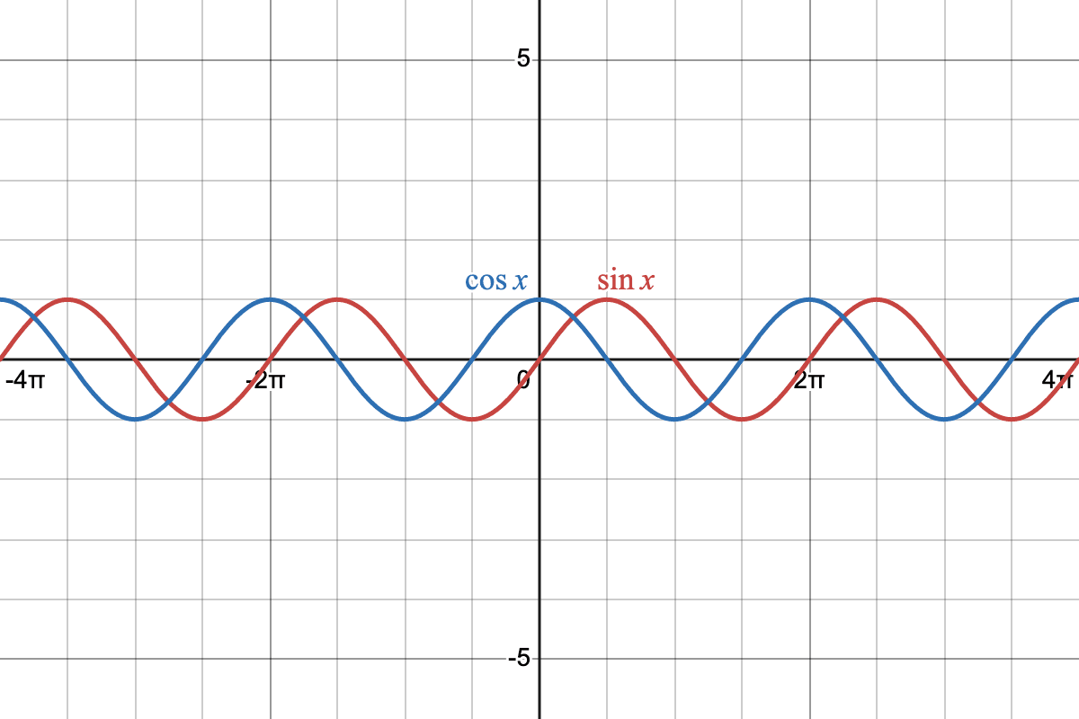

Note: The cosine function is essentially a horizontal shift of the sine function by rad or 90°.

3.7.1.2. Tangent
The tangent function is defined as . Its properties include:
- A period of radians or
- An undefined value at odd multiples of (i.e. , , , , etc.)
- An unbounded range (all real number)

The graph of looks like this:
